**RURAL FINANCIAL INCLUSION DEVELOPMENT**

Field study submitted in partial fulfillment

*of* the requirements *for* the degree *of*

### **MASTER OF COMPUTER APPLICATIONS**

#### to the

Thiruvalluvar University, Serkkadu, Vellore-636 106.

**A Field Study Submitted**

By

### **VINITH.B**

**REG NO : 31022P08011**



**SEPTEMBER 2023**

PG DEPARTMENT OF

COMPUTER SCIENCE AND APPLICATIONS

GOVERNMENT THIRUMAGAL MILLS COLLEGE

GUDIYATHAM, VELLORE DIST -632 602

# GOVERNMENT THIRUMAGAL MILLS COLLEGE

Gudiyatham, Vellore - 632602.

#### (Affiliated to Thiruvalluvar University)

BONAFIDE CERTIFICATE

Certified that this field study report titled “ **RURAL FINANCIAL INCLUSION DEVELOPMENT** " is the bonafide of work done by **VINITH.B (Reg.no: 31022P08011)** to Government Thirumagal Mills College, Gudiyatham in partial fulfilment of the requirement for the award of the degree of Master of Computer Applications is a record of bonafide work carried out by him under my guidance. The Field Study the requirement as per the regulations of this institute and it meets the necessary standards for submission.

Dr. K. ARULANANDAM Dr. K. VIJAYARANGAM Dr. K. ARULANANDAM

(PROJECT GUIDE) (OTHER DEPARTMENT) (HEAD OF DEPARTMENI)

Submitted for the Fifth-semester examination field study work held on

#### External Examiners

1.

2.

DECLARTION

### I hereby declare that the field study entitled "RURAL FINANCIAL INCLUSION DEVELOPMENT” submitted by me to **Government Thirumagal Mills College, Gudiyatham** in partial fulfilment of the requirement for the award of the degree of **MASTER OF COMPUTER APPLICATIONS** is a record Of Bonafide Field Study work carried out by me under the guidance of Dr. K. ARULANANDAM. I further declare that the work reported in this Field Study has not been submitted, either in part or in full, for the award of any other degree or diploma in this institute or any other of university.

#### Candidate Signature

**Place:** Gudiyatham

**Date:**

**ACKNOWLEDGEMENT**

I express my gratitude to our beloved Principal **Dr. G. KRISHNAN M.A., M.Phil., M. ED, Ph.D.,** Government Thirumagal Mill’s College Gudiyatham, for providing the resource facilities and encouraging gesture for completion of my Field Study.

I wish to express my deep sense of gratitude and heartiest thanks to our professor **Dr. K. ARULANANDAM, MCA., M.Phil., Ph.D.,** Head of the Department of MCA, Government Thirumagal Mills College, Gudiyatham.

I am much privileged to have **Dr. K. ARULANANDAM, MCA., M.Phil., Ph.D.,** and lecture in MCA Department as my guide for this my Field study. I heartily thank for her overall help and support at all stage.

I also take an opportunity to thank all the TEACHING and NON­ TEACHINO STAFF for their fullest and valuable assistance provided in this field study work.

Last but not the least, I own my special thanks to my beloved all my friends and family member for their help in finishing this field study successfully.

Place: Gudiyatham Submitted by

Date: **VINITH.B**

ABSTRACT

Recently India has taken several steps towards financial inclusion for achieving faster inclusive growth.

This study seeks to examine the achievement of the Indian states regarding the financial inclusion. Applying the methodology of Rotated Principal Component Analysis this study has computed a comprehensive measure of financial inclusion for each state.

For this analysis ten indicators of financial Inclusion have been considered.

This study has used the data published by the Reserve Bank of India (RBI) and the Government of India.

Ranks of the states in accordance with the Composite score show that although the state of Goa is the best, most of the states in southern region have performed better in terms of financial inclusion.

However, the levels of financial inclusion of the states in India have a low mean and high disparity.

This study has revealed a strong positive association between the human development and the financial inclusion of the states in India.

Financial inclusion is an emerging economic growth paradigm, especially in developing economies like India. It is an essential barometer for the all-encompassing growth of a country and its economy.

However, there is still a debate regarding the effect of Financial Inclusion (Fl) on achieving sustainable development. This study aims to determine if Fl helps achieve Sustainable Development Growth (SDG) in India and if internet subscribers significantly influence the connection between Fl and SDG.

Secondary data from 16 states and one UT in India have been collected for 2017-2019. The findings of this research are that Fl has a positively significant relationship with sustainable development goals (SDG) in India.

When the internet subscribers are high, the Fl's positive association with SDG gets reduced. PMFBY and SDG have been used for the first time, along with internet subscribers as moderators. The outcome has direct policy implications for improving the nation's financial inclusion and economic growth.

Keywords: Financial Inclusion, Principal Component An

LIST OF TABLE

|  |  |  |
| --- | --- | --- |
| **S.NO** | **CONTESTS** | **PAGE.NO** |
| **1** | **INTRODUCTION** | 1-4 |
| **2** | **MANAGEMENT OF FINANCIAL SERVICES** | 5-6 |
| **3** | **FINANCIAL INCLUSION TOWARDS RURAL**  **DEVELOPMENT IN INDIA: ISSUES AND CONCERNS** | 7-12 |
| **4** | **IDENTIFYING VARIOUS SOURCES CONTRIBUTING TO IMPROVE FINANCIAL INCLUSION** | 13-24 |
| **5** | **FINANCIAL INCLUSION - A RETROSPECTION** | 25-30 |
| **6** | **FINTECH FOR FINANCIAL INCLUSION** | 31-34 |
| **7** | **FINANCIAL INCLUSIONS RURAL WOMEN ENTREPRENEURSHIP** | 35-38 |
| **8** | **FINANCIAL INCLUSION IN INDIA** | 39-44 |
| **9** | **FINANCIAL INCLUSION OF RURAL**  **INDIA:CHALLENGES & OPPORTUNITIES** | 45-49 |
| **10** | **CONCLUSION** | 50 |
| **11** | **BIBILOGRAPHY** | 51 |

INTRODUCTION

* Financial Inclusion is described as the method of offering banking and financial solutions and services to every individual in the society without any form of discrimination. It primarily aims to include everybody in the society by giving them basic financial services without looking at a person's income or savings.
* Financial inclusion chiefly focuses on providing reliable financial solutions to the economically underprivileged sections of the society without having any unfair treatment. It intends to provide financial solutions without any signs of inequality.
* It is also committed to being transparent while offering financial assistance without any hidden transactions or costs.
* Financial inclusion wants everybody in the society to be involved and participate in financial management judiciously.
* There are many poor households in India that do not have any access to financial services in the country. They are not aware of banks and their functions.
* Even if they are aware of banks, many of the poor people do not have the access to get services from banks.
* Microfinance is a small-scale financial service offered to the poor by financial institutions.
* Savings, credit insurance, lending, money transfers, equity transactions, and other financial services are examples of financial services offered to consumers to fulfill their usual financial needs during their life cycle, economic opportunity, and emergency.
* A Self-Help Community (SHG) is an unregistered or registered group of micro entrepreneurs who come together voluntarily to save small amounts of money on a regular basis, to collectively agree to contribute to a shared fund, and to meet their emergency needs on a mutual help basis. It is a self-organized group of people who have come together to achieve a common goal.
* It is a voluntary association of people formed to attain certain collective goals, both economic and social. Each group has 10-20 people in it.
* A group could be exclusively male or female, or even mixed. However majority of SHG's are female groups.

1. Objectives
2. To the study significance and role of financial inclusion in the M icro Fi nanci a I Institutions (MFIs)
3. To investigate the various Micro Finance Institutions in Indiato promotefinancial inclusion.
4. To list features and the accomplishments of Micro Finance Institutions.
5. Literature Review

Milana, C, Ashta states in their study that the ultimate goal and raison d'etre of microfinance is to lift the poor out of poverty through financial and social inclusion. Microfinance institutions have done a good job of administering microcredit, according to recent literature, but their goal of improving the living standards of their indigent clients has not been reached in most cases.

Encouragement of entrepreneurship is predicted. Microcredit's intended promotion of entrepreneurship, let alone women's social involvement in work activities, is to be seen in empirical evidence.

The papers in this thematic issue create new analytical elements to the debate, highlighting a variety of elements of the social divisions and disparities that threaten developing countries. This overview article summarises the major unanswered questions as well as the Jayati Ghoshin the article represents an important assessment of microfinance's success in developing countries based on a study of recent literature.

It looks at India'shistory, which has one of the world's largest microfinance industries, and in particular the microfinance crisis in Andhra Pradesh. It reaches the conclusion that microfinance cannot be regarded as a panacea for progress.

It must be regulated and subsidized to accomplish even some of its social objectives, and other strategies for sustainable financial inclusion of the poor and small producers must be embraced more aggressively.

Some of the significant features of microfinance are as follows:

1. These loans are usually repaid at higher frequencies
2. Loans availed under microfinance are usually of small amount, i.e., micro loans
3. The loan tenure is short
4. The purpose of most microfinance loans is income generation
5. Microfinance loans do not require any collateral
6. The borrowers are generally from low income backgrounds

ICICI Bank

* For at least ten years, ICICI Bank has partnered with MFIs to providemicrofinance loans to these Organisations. The bank is currently concentrating on the following:
* Establishing a successful and sustainable lending market with a select group of MFIs
* Investing in India's microfinance industry to ensure its long-term viability.

State Bank of India (SBI)

SBI provides loans to microfinance institutions and non- governmental organisations (NGOs) that serve as intermediaries in funding the needs of low-income entrepreneurs. Cash credit loans should be renewed on an annual basis and havea maximum maturity period of three years.

Axis Bank

Axis Bank provides loans to microfinance institutions that help low- income earners and micro entrepreneurs become financially self-sufficient.

Several MFIs have partnered with the bank across the country. The bank provides term loansto MFIs, who then extend them to qualifying borrowers.

Microfinance Companies in India

The following are some of the microfinance companies in India that provide loans to the unbanked and under banked:

1. Arohan Financial Services Pvt Ltd:
2. DishaMicrofinPvt Ltd
3. Annapurna Microfinance Pvt Ltd
4. BSS Microfinance Pvt Ltd
5. Cashpor Micro Credit
6. Asirvad Microfinance Pvt Ltd
7. Equitas Microfinance Pvt Ltd
8. ESAF Microfinance and Investments Pvt Ltd
9. Bandhan Financial Services Pvt Ltd
10. Fusion Microfinance Pvt Ltd

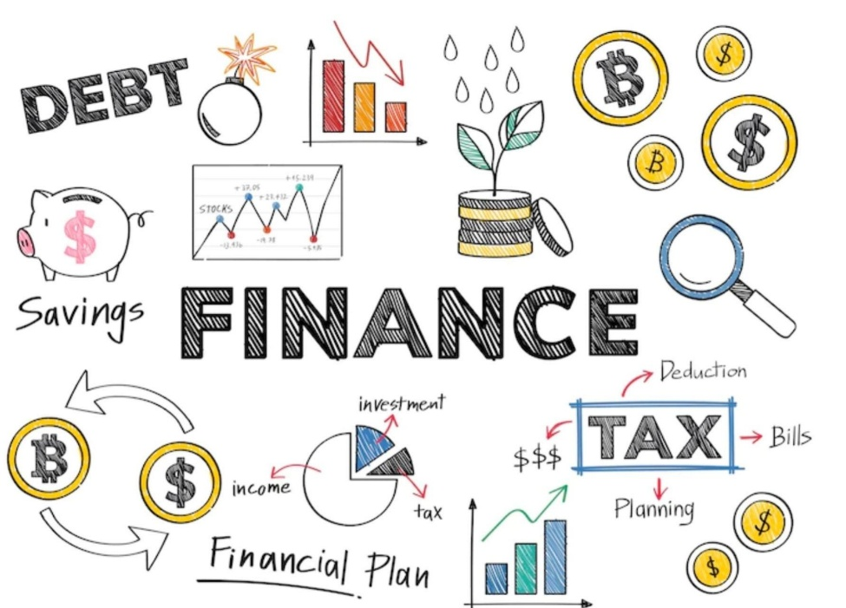

MANAGEMENT OF FINANCIAL SERVICES

Meaning:

All types of activities which are of a financial nature could be brought under the term 'financial services'.

The term "Financial Services" in a broad sense means "mobilizing and allocating savings". Thus, it includes all activities involved in the transformation of saving into investment.

The 'financial service' can also be called 'financial intermediation'. Financial intermediation is a process by which funds are mobilized from a large number of savers and make them available to all those who are in need of it and particularly to corporate customers.

A well-developed financial services industry is absolutely necessary to mobilize the savings and to allocate them to various investable channels and thereby to promote industrial development in a country.

Classification of financial services industry The financial intermediaries in India can be traditionally classified into two:

1. Capital market intermediaries.
2. Money market intermediaries.

The capital market intermediaries consist of term lending institutions and investing institutions which mainly provide long term funds. On the other hand, money market consists of commercial banks, co-operative banks and other agencies which supply only short term funds.

Scope of financial services:

Financial services cover a wide range of activities. They can be broadly classified into two namely:

1. Traditional activities.
2. Modern activities.

Traditionally, the financial intermediaries have been rendering a wide range of services encompassing both capital and money market activities. They can be grouped under two

1. Fund based activities and
2. Non-fund based activities.

Fund based activities:

1. Underwriting of or investme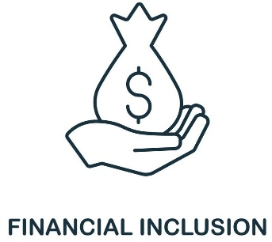nt in shares, debentures, bonds etc. of new issues (primary market activities)
2. Dealing in secondary market activities
3. Participating in money market instruments like commercial papers, certificate of deposits,

treasury bills, discounting of bills etc.

1. Involving in equipment leasing, hire purchase, venture capital, seed capital etc.
2. Dealing in foreign exchange market activities.

Non-fund based activities:

* + Financial intermediaries provide services on the basis of non-fund activities also. This can also be called "fee based" activity. A wide variety of services, are being provided under this head. They include the following:
  + Financial inclusion means that individuals and businesses have access to useful and affordable financial products and services that meet their needs-transactions, payments, savings, credit and insurance - delivered in a responsible and sustainable way.
  + A transaction account can also serve as a gateway to other financial services, which is why ensuring that people worldwide can have access to a transaction account is the focus of the World Bank Group's Universal Financial Access 2020 initiative.
  + Financial access facilitates day-to-day living, and helps families and businesses plan for everything from long-term goals to unexpected emergencies.
  + As accountholders, people are more likely to use other financial services, such as credit and insurance, to start and expand businesses, invest in education or health, manage risk, and weather financial shocks, which can improve the overall quality of their lives.
  + While there has been progress toward financial inclusion, significant challenges remain:
  + An estimated 2 billion adults worldwide don't have a basic account.

FINANCIAL INCLUSION TOWARDS RURAL DEVELOPMENT IN INDIA: ISSUES AND CONCERNS

* Conceptualizing Financial Inclusion and Rural Development It is important to define and conceptualize the Fl.
* We can discuss with the help of following definitions.
* Financial inclusion could also be defined because the process of enhancing access to financial services timely and adequate credit needed by vulnerable groups such as weaker sections of society at a reasonable cost. (Dr. C.Rangarajan 2008)
* Financial Inclusion is broadly defined as universal access to a wide range of monetary services at a reasonable cost.
* These include banking products and other financial services like insurance and equity products.(Dr.Raghuram G.Rajan 2009)
* The actual meaning of financial inclusion is availability of financial services which include bank accounts for savings and transactional purposes with less required documentation, less-cost credit for individual and business purposes, financial advisory services, and insurance facilities (life and nonlife) etc.
* Financial inclusion facilitates the habit of savings among the rural populations and plays its own role in the course of economic development.
* Further, by bringing low income groups within the edge of formal banking sector Development is the condition of progress, and when efforts are laid towards the employ of Growth potentials in rural economy and Society, it is known as rural development.
* As a concept, it can say that overall development of rural areas with a vision to improve the quality of life of rural people.
* In this view it's a inclusive and multidimensional concept and encompass the event of agriculture and allied activities village and cottage industries and crafts, socioeconomic infrastructure, community services and facilities, and in particular, the human resources in rural areas.
* Rural Development is an approach to enable a selected group of individuals like poor, rural women and men to develop for themselves and their future children more of what they need and wish.
* The group includes small-scale farmers, Since rural development is nothing but a way to reduce poverty, it must clearly be designed to extend production and lift productivity. It is assumed that improved food supplies and nutrition, together with basic services such as health, education and cultural activities would directly develop the physical wellbeing and quality of life of the rural poor, but also indirectly develop their productivity and capability to contribute to the national economy.

Theoretical Literature and Empirical Literature

* It will create the global opportunity to inclusive growth.
* It has taken many steps to forward to achieve the inclusive growth that is there were only 8000 plus bank branches in 60s but now it is 99000 plus, it clearly shows that there is a penetration in banking sectors.
* In financial inclusion are Gujarat, Assam, Manipur, Bihar, Uttar Pradesh and Madhya Pradesh etc.
* Compared to other developing countries 48 percent of Indian population having access to financial services whereas 59 percent in Sri Lanka.
* In 2006 RBI initiated to establish 50 percent of bank branches in Unbanked Areas.

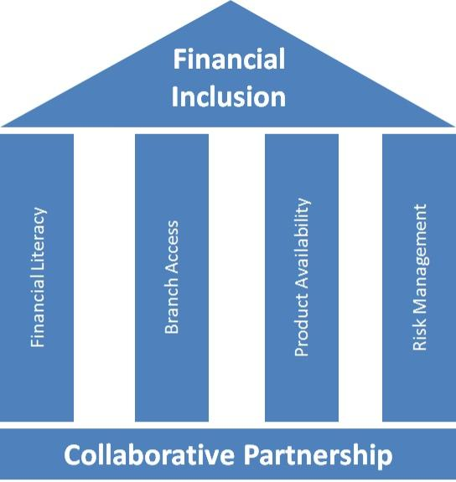

Objective of the Study

The purpose of the study is to guage the necessity of monetary Inclusion in India. In order to achieve this objective the following issues have been examined:

1. To examine the extent of financial exclusion in rural India.
2. To examine the present status of financial inclusion in India.

Research Methodology

* The present study is predicated on the secondary data.
* The necessary secondary data resources has been collected from the various sources like as Annual Reports Ministry of Rural Development Government of India, RBI Annual Reports, RBI Report on Trend and Progress of Banking and all other publications of the RBI.
* The period of study is from 2015 to 2020 taking into account the data availability as well as the latest and update data possible.

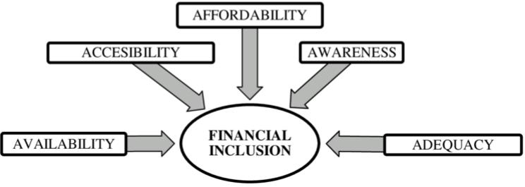

* As per Census 2011 Government of India, only 58.7 percent of households are utilizing banking services in the India.
* However, as compared to earlier census 2001, availing of banking services increased drastically largely on account of increase in banking services in rural India.
* CRISIL Financial Inclusion Index (Fll) (Inclusix) states that, June 2013, for constructing the index, CRISIL identified three significant parameters of basic banking services that are branch penetration, deposit penetration and credit penetration.
* The CRISIL Inclusix found out that there is an overall development in the financial inclusion in India. CRISIL -Inclusix (on a scale of 100) increased from 35.4in March 2009 to 37.6 in March 2010 and to 40.1 in March 2011.
* Financial Inclusion:
* RBI policy Initiatives:
* RBI has implemented a bank led model to achieve financial inclusion with removing the all other regulatory restrictions in achieving better financial inclusion in the country. RBI has also initiated regulatory environment and provided institutional support for banks in accelerating the financial inclusion efforts contains Basic Saving deposit, Relaxed Simplified KYC Norms, simplify Branch Authorization Policy, Compulsory Requirement of Opening Branches in Unbanked Villages, Opening of intermediate brick and mortar structure, Three Year Financial Inclusion Plan.FIP disaggregated and percolated at down up to branch level, Financial Literacy Centers.
* Present status of Financial Inclusion in Rural India:

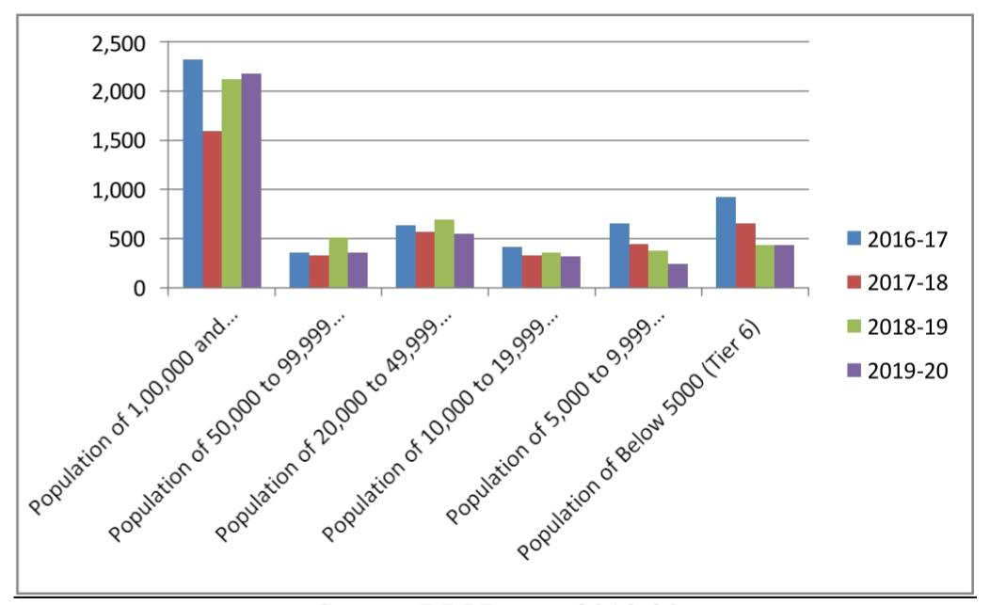

* The picture shows that decline in the number of latest bank branches during 2019-20 was mainly because of SFBs, RRBs and PBs.
* PVBs and SFBs maintained the lead in opening new branches as part of their business expansion Strategy. During the year, more than half of new branches were opened in Tierl centers, although fewer branches were opened in other higher tier centers.
* The geographical distribution of ATMs across rural land urban areas remained broadly similar in 201920 to that in the previous year. The concentration of ATMs remains skewed towards urban customers.

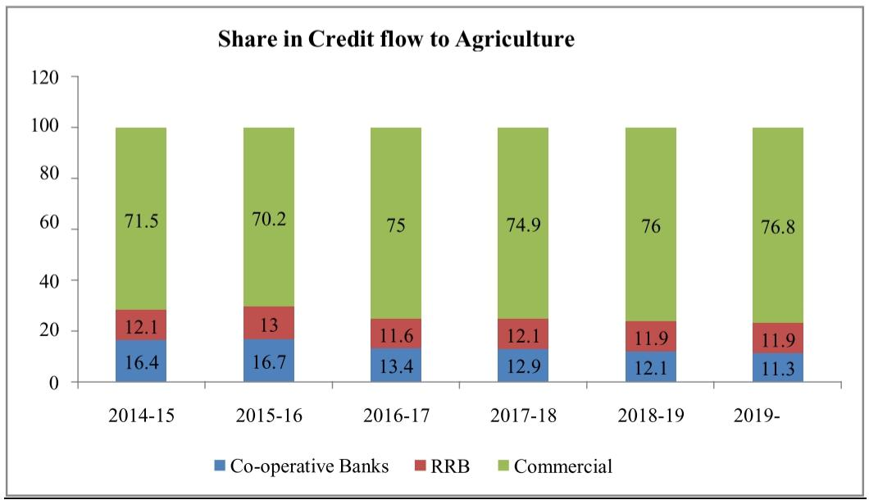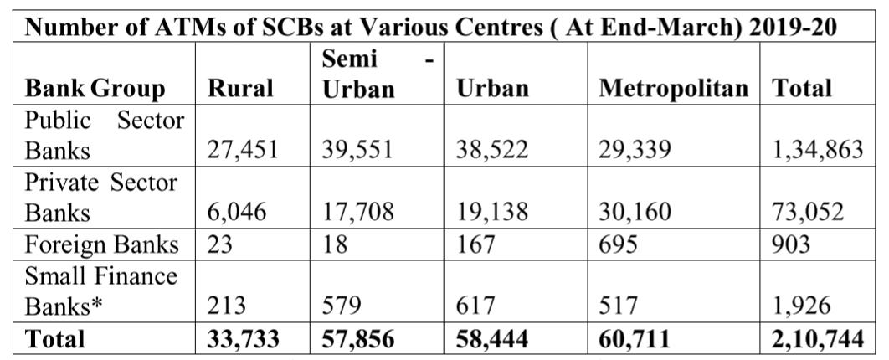

IDENTIFYING VARIOUS SOURCES CONTRIBUTING TO IMPROVE FINANCIAL INCLUSION

* Monetary framework is the foundation of the economic development and they act as a multiplier and mediator for economic stability.
* The process of economic growth must include the participation of all sections of the general public.
* In India major portion of the group is lack of access to formal financial services due to this many are turning towards informal financial services which bears huge cost.
* It is recognized as a serious threat to economic progress, especially in developing countries.
* To conquer such deterrents, the financial areas came out for certain mechanical advancements, for example, ATMs, Credit and charge cards, Internet and versatile banking, UPI exchanges and so on.
* Although presentation of these sorts of developments got numerous progressions in metropolitan culture, lion's share of the country populace is still absence of mindfulness on these progressions and are barred from formal financial administrations.
* Financial inclusion is a technique for offering banking and monetary services to people which tries to include every general public by offering them essential monetary elements and services required by vulnerable groups at a moderate expense in a straightforward way by monetary foundations.
* The targets of financial inclusion are to offer a basic no-frills account for;
* making and accepting payments;
* saving products;
* simple credit products and overdrafts connected with no-frills account;
* settlement, or cash transfer facilities;
* micro and non-micro insurance (life and nonlife) and micro benefits.

Literature Review

* Financial inclusion can be understood as the keystone of the economic development. A study made on financial inclusion indicated that it is in a progressive stage in India in terms of branch penetration, but certain efforts towards inclusive growth are still in nascent stage (Paramjit Sujlana et.al 2014). Sherline T.l (2017) in her research concluded that undoubtedly.
* Financial inclusion is acting as a catalytic role for the economic and social development of society but still there is road ahead to achieve the desired outcomes.
* Despite the fact that endeavors are being made by all partners viz, Regulators, Government, monetary foundations and others, the endeavors are not yielding the sort of result anticipated.
* The regulators have to create a suitable monitoring environment that would protect the interest of all the stakeholders" (Agarwal, 2014).(Sethy, 2016)ln his study, he has proposed a financial inclusion index to determine the extent of financial inclusion across economies. Both supply side dimensions like across to savings, insurance, bank risk and demand side dimensions.
* It was observed that India is categorized on high financial inclusion on demand and low financial inclusion of supply side. It was recommended that GOI and RBI adopt adequate policy measures to improve supply side dimension of financial inclusion.
* For the analysis of financial inclusion ten indicators have been considered. However, the degrees of financial inclusion of the states in India have a low mean and high disparity.
* It is disclosed from the study that the human advancement and the financial inclusion of the states in India have positive association(Bagli, 2012). (Banerji, 2018) In continuation with the previous studies, the author has studied the tools of ICT used for enabling financial inclusion in India.
* Though various efforts taken by the stakeholders to ensure access of financial products and services to feebler and under privileged segments of the society but financial illiteracy, lack of convenience, technological issues and viability has emerged as significant impediments the path of achieving inclusive growth.
* (Dhar & A. Barua, 2020) Although various initiatives have been embark on to improve outreach in banking sectors, achievement is not a significant one.
* Assam has a constant poor performance in all three dimensions of financial inclusion

Research Methodology

The methodology undertaken for the present study is explanatory in nature.

Data and information collection for this study is done through secondary sources i.e., with the help of books, newspapers, magazines, research articles, journal publications, e-journals, RBI annual reports, NABARD report etc.

1. To understand the financial inclusion and its vital role in economic development.
2. To trace out the various approaches adopted by financial institutions and various initiatives taken by Government and regulatory bodies to improve financial inclusion.

* Need of the Financial Inclusion: Financial exclusion is the absence of access by certain consumers to appropriate, low cost, fair and safe financial products and services from conventional providers.
* There is a large overlie between poverty and permanent financial exclusion.
* Deprivation and financial exclusion both result in decline of choices which affects social interaction and leads to reduced participation in society.
* Financial Exclusion leads to Financial Discrimination, Financial Exploitation and Financial Illiteracy.
* It is seen that 1.7 billion individuals are unbanked as per the World Bank Findex report.
* Due to difficulties in accessing official sources of credit, poor individuals and small and macro enterprises usually rely on their personal savings or internal sources to invest in education, health, housing, and entrepreneurial actions to make use of development opportunities.
* As the breach between the metropolitan and rustic areas increase as an outcome of such exclusions, inclusive growth becomes more complex to achieve, adversely disturbing the growth rate of the country.

Financial inclusion

Concept and Definition of Financial Inclusion:

* Financial inclusion is one of the significant perspectives in the current situation for inclusive improvement and development of economies.
* The committee in Financial Inclusion (C Rangarajan, 2008) defines financial inclusion as the -process of ensuring access to financial services and timely and adequate credit where needed by vulnerable groups such as weaker sections and low-income group at an affordable cost.||
* It does not mean the delivery of financial services for everyone at all cost.
* But it indicates that the delivery of financial products and services at reasonable costs of excluded sections of population and low-income groups.
* It portraysa significant role to wash out the poverty from the country, which offers a path for inclusive growth.
* Financial inclusion comprises various other services such as insurance, savings, payment and remittance facilities by the conventional financial system to those who have been barred as banking.
* Services are in the nature of public good, it is crucial that accessibility of banking and payment services to the entire population without prejudice is the main objective of the public policy.

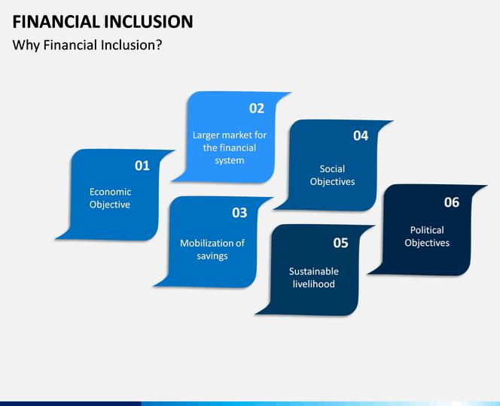

No-frills Account: RBI has introduced,,no-frills account" in 2005 to provide fundamental banking services to poor and promote financial facilities.

The account can be continued without or with very low minimum balance.

Later in 2012, banks under RBI originated with a better version of the no-frills account where they would open Bank Savings Bank Deposit Accounts(BSBDAs)for all persons with the facility of a free debit card, cheque book, mobile and internet banking and access to ATMS, overdraft limits at nominal charges.

However, number of transactions/withdrawals could be monitored so as to counteract misuse of such accounts.

As a part of financial inclusion, Prime Minister has come up with a programnamed Pradhan Mantri Jan Dhan Yojana (PMJDY) targeting at expanding and making affordable services to financial services to the last man in the row.

Since its inception on August 15,2014 till June 18 2018, over 31 crore bank accounts were opened and over Rs. 7,92,00 crore were deposited under the scheme.

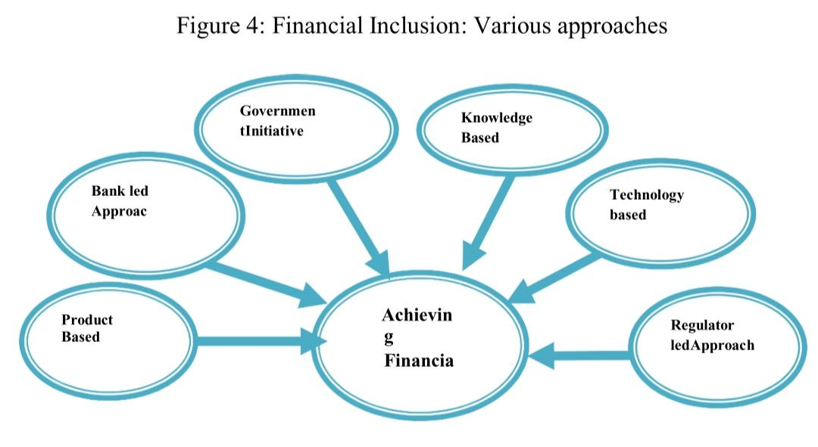

General Purpose Credit Cards (GCC):

* RBI launched this scheme in 2005 and gaverules and regulations to the banks to launch and offer general credit card services with a measure of upto Rs. 25000 at their branches situated in semi-urban and rural regions.
* Later in Dec 2013 according to revised rules, banks additionally needs to satisfy Non-farm entrepreneurial credit requirement of individuals and under this credit there will be no upper limit on loan amount.
* Security standards will be pertinent according to RBI regulations on guarantee free lending for micro and small units issued from time to time.(Agarwal, 2014)
* Savings account with overdraft facility: Banks have been encouraged to give overdraft facility saving account and furthermore small overdraft in No-frills account.
* The setting up of threshold for the equivalent would be finished by banks thinking about the exchanges in the account.
* This would assist clients with getting simple admittance to the credit at lower rates. (Jayasree, 2016)
* According to various research studies and an action research project carried out by NABARD, the model of SHG-BLP" has evolved as accost-effective mechanism for providing financial services to the unreached poor households.
* What started around 500 SHGs of poor to the formal financial institutions during the year 199293 has now became the largest microfinance programme in the world, in terms of the client base and outreach.
* While the nuts and bolts of SHGs being saving driven credit product stay genuine today, recent improvements have brought about relook in the methodology and plan of this genuinely fruitful model prompting SHG-2.

The basic features of SHGs are:

1. Voluntary savings apart from compulsory savings.
2. Allowing the approval of a cash credit/overdraft system of lending for SHGs for a longer tenure.
3. Graduating chose individuals from the gathering that have business potential into a joint accountability groups for acquiring bigger sums.

* Simplified KYC Norms: KYC is an interaction by which banks acquire data about the identity and address of the client, to guarantee that the bank services are not misused.
* While opening accounts KYC methodology is to be finished by the banks and furthermost update them occasionally.
* Under KYC standards, a client needs to deliver number of documents for opening account as per RBI rules.
* However, this has become an issue to the people in rural areas and to tap this issue RBI has loosened up various standards for accounts opened by individuals who intend to keep balances not surpassing Rs.50,000 and whose absolute credit in all the accounts taken together is not expected to surpass Rs. 100,000 in a year.
* Small accounts can now opened on this premise of a presentation from another account holder who has fulfilled all KYC standards.
* Further, RBI has permitted —Aadhaar|| by UIDAI, GOI to be utilized as one of the qualified report for meeting the KYC necessity for opening a ledger

|  |  |  |  |  |  |
| --- | --- | --- | --- | --- | --- |
| **Particulars** | **2015** | **2016** | **2017** | **2018** | **2019** |
| Number of registered mobile money accounts per 1,000 adults | 73.29 | 221.94 | 443.52 | 541.94 | 1,264.79 |
| Value of mobile money transactions (during the reference year) (% of GDP) | 0.06 | 0.13 | 0.31 | 0.57 | 0.90 |

* Mobile Banking: The most wonderful improvement regarding development to use the full force of innovation, the banks have tied up with versatile administrators to offer monetary types of assistance like service bills and installments, ticket booking, store move, shopping and so forth a few models are Google pay, Phonepe, Paytm, Payzap by HDFC,YONO by SBI and so on
* Increase in ATMs: RBI also reported that many rural parts of the nation do not have enough automated teller machines (ATMs) and this is hampering many purchasing and selling tasks of individuals dwelling in those territories.
* To expand the accessibility of actual money for these individuals, the number of ATMs expanded enormously.
* Additionally banks have utilized the innovation to empower their ATMs to basically act like a 24x7 branches.

Branchless Banking:

* A portion of main banks have come up with this idea where there would be an online framework with chat facility helping the individuals to utilize different electronic machines for saving and pulling out money and cheques.
* Anyway this activity is in a very initial stage and has a limit regarding starting cost for banks and literacy *I* knowledge for the rural population and henceforth this idea is presently limited to urban and semi-urban territories.
* Aadhaar Enabled payment services:
* The new presentation of direct benefit transfer for validating the character of the recipient through Aadhaar will help enable providing of social welfare benefits by direct credit to the ledgers of recipients.
* The public authority, in future, has plans of directing all social security payments through the financial organization utilizing the Aadhaar based stage as a unique financial address of recipients.
* This will not just diminish the delay in the advantages being obtained by the end user, yet additionally lessens the odds of corruption in the distribution of the benefits under the schemes. Additionally, the one-of-a-kind biometric ID information put away in the Aadhaar data set is relied upon to engage a bank client to utilize Aadhaar as his/her personality to get to different monetary administrations.
* Financial inclusion, financial education and financial stability are the three significant things of a crucial technique, as demonstrated in the figure above.
* While monetary incorporation works from supply side by giving admittance to different monetary administrations, monetary schooling takes care of the demand side by advancing mindfulness among individuals in regards to the requirements and advantages of monetary administrations offered by banks and different organizations.
* Moving ahead, the above two techniques advance more prominent monetary stability.

Government Initiatives:

* Government has taken different activities indirectly through the controllers, government promoted programs through its different agencies. Some of them are recorded underneath:
* Pradhan Mantri Jan Dhan Yojana (PMJDY): About 192.1 million accounts have been opened under this plan.
* These no-frills bank accounts have been supplemented by 165.1 million debit cards, an accidental and life insurance cover of Rs 1 lakh and Rs 30,000 respectively.
* There are few different schemes in India - Jeevan Suraksha Bandhan Yojana (JSBY), Pradhan Mantri Vaya Vandana Yojana (PMVVY), Venture CaptialFUnf for Scheduled Castes Under the Social-sector initiatives, Atal Pension Yojana, Varishtha Pension Bima Yojana (VBPY), Sukanya SamriddhiYojana(SSY), Credit Enhancement Guarantee Scheme (CEGS) for the scheduled castes.
* Policy measures such as the Pradhan Mantri Jan Dhan Yojana, persistent focus on the unbanked regions have driven lndia"s financial inclusion agenda over past 3 years||(Suyash, 2018)

1. Swarnjayanti Gram Swarozgar Yojana (SGSY), launched by Ministry of Rural Development to help the helpless families living underneath poverty line and rural areas for taking up self-employment. This scheme is subsidized by Central Government.
2. Aajeevika - National Rural Livelihoods Mission (NRLM) was initiated by the Ministry of Rural Development of India in 2011 June. The mission targets making productive and powerful institutional foundation of the rural poor, empowering them to expand household income through sustainable livelihood enhancements and improved access to monetary administrations.
3. Aadhaar - UIDAI: Introduced by GOI to give an individual ID number to each resident of India in 2009; it set up the UIDAI to give these cards on behalf of GOI.
4. This number will likewise empower individuals to approach administrations like banking, cell phone network and other government & nongovernment services.
5. Besides this, UIDAI has introduced a framework in which the unbanked population will be able to open an account during enrolment with Aadhaar without going to a bank.
6. Mahatma Gandhi National Rural Employment Guarantee Scheme (MGNREGA):
7. The Centre has allocated 73 thousand crore rupees to the country work ensure program MGNREGA for the following monetary 202122||, where this plan targets to improve the livelihood of rural individual by ensuring at least 100 days of wage employment in a monetary year to a rural household whose adult members volunteer to accomplish untalented manual work

* As on 31 March 2020 a cumulative amount of ?4,252 crore was sanctioned, and an amount of ?2,276 crore is disbursed towards various schemes implemented under FIF (Financial Inclusion Fund) by generating demand for banking services and building payment/acceptance infrastructure at the ground level.
* To link the disparity between the demand and supply side of Fl, a discriminated policy approach was adopted to address the regional disparities and to get about inclusive and equitable financial inclusion across the country (NABARD-Achievements, 2020).
* VI. Financial Inclusion and Indian Banking network RBI has urged monetary organizations to carry out an arranged and organized Financial Inclusion Plans (FIPs) for the improvement and development of the country.
* The FIPs have been used by RBI for accessing the performance of financial institutions under their Financial Inclusion initiatives.
* The table underneath shows the number of bank accounts have been opened during this period and formed a major financial organization the country over.

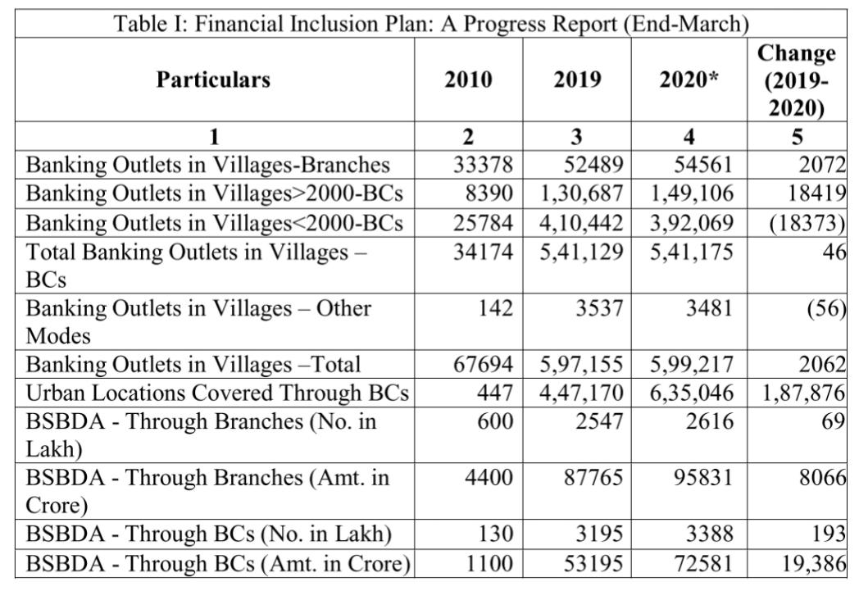

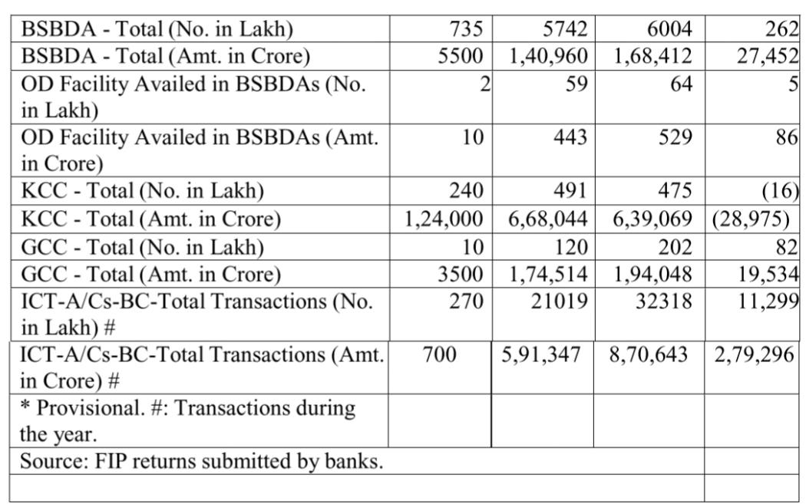

FINANCIAL INCLUSION - A RETROSPECTION

Financial inclusion is the access to useful and affordable financial products.

1. Services that meet their needs,
2. Transactions,
3. Payments,
4. Savings, Credit,

* Insurance - delivered in a responsible and sustainable way to individuals and businesses (The World Bank).
* Financially included individuals are those who have an account in their name with a full-service financial institution.
* Financial inclusion is created through the uptake and use of individual accounts with institutions that offer financial services like - savings, credit, money transfers, insurance and investment.
* Banks, mobile money service providers, and nonbank financial institutions, such as deposit-taking microfinance institutions (MFIs) and financial cooperatives are all part of Full-service fina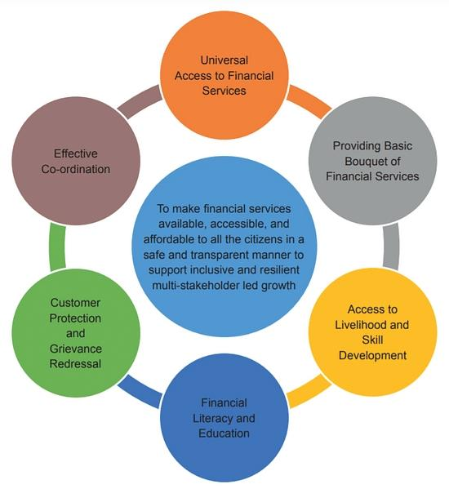ncial institutions

Benefits of Financial inclusion;

* is an important benchmark of the socio-economic
* it enables of poverty alleviation &
* Boosts prosperity.

It bridges the gap between rural and urban by ensuring that people across the country get.

* access to easy online.
* Banking facility and reliable daily payments.

Financial inclusion includes rural masses.

* easy access to credit for small-scale revenue-generating businesses.
* opportunities to invest for unforeseeable risks.
* Insurance products.

There are a few setbacks for the implementation of financial inclusion like, Dearth of high-end.

* Lack of awareness and trust in digital payments.
* affordable and reliable internet connectivity options.
* The large size of the unbanked population spread across vast geographies.
* Limited access to credit,
* High loan default rates and
* Lack of financial literacy.
* The reluctance from the side of financial institutions to serve small value.
* and a feeling of obligation
* The growing number of cyber security issues
* Lack of proper awareness and knowledge.
* Corruption.
* Inadequate rural banking infrastructure.

1. Objectives of the Study;

To discuss the benefits of financial Inclusion

To study the challenges for implementation of financial inclusion in India

1. Literature survey;

Rohit Kumar, (2021), states that investments in physical and social infrastructure as well as in need-based products are required. Financial literacy plus an innovative way of delivery is need of the hour so as to ensure inclusive growth of the economy. Further, there has to be focus on tailor made tailor-made services. Credit disbursement should be more flexible to attract the masses that are used to informal sources of credit. A better delivery infrastructure efficient and secure should be provided eliminating multiple layers of governance, leverage modern technology: better participatory role should be encourages; procedures should be made simple.

In August 2014, "Pradhan Mantri Jan-Dhan Yojana" (PMJDY) scheme was announce by Prime Minister Narendra Modi to overcome the vices of black money in the economy and provide 75 million Indians zero-balance bank accounts who did not have accounts in banks. Therefore the people could have access to a range of financial services, like pension, credit and insurance.

Bank accounts are the main parameters of financial inclusion.

The other initiatives by the Government of India were.

• Digital financial services (DFS) through Aadhaar biometric identification Aadhaar cards are being linked with mobile phones, SIM cards and financial service accounts to improve delivery of government schemes and benefits

1. Research Methodology;

The methodology undertaken for the present study is explanatory in nature. Data and information collection for this study is done through secondary sources i.e..ejournals, "Finclusion" survey reports, etc.

1. Discussion;

The proportion of the financially included population grew from 54% to 81%. Between 2014 and 2018. It has been observed that over the years the Government of India is making a conscious effort to increase the financial Inclusion of the masses. We can observe it by the report of survey conducted by Inter India Fll Tracker surveys. The data ranges from year 2014 to year 2018. The has increased considerably from 9 percent to 15 percent in Non-bank financiar Institutions, 52 to 82 percent in banking facilities, 0.3 to 2 percent in mobile money, overall 55 to 83 percent in NBFI, bank and mobile money.

* Truly the benefits are what the world is opting as the best solution for removal of poverty and differences amongst various groups like rural, urban, male female etc.
* It is a commendable work the Government of India has taken up the herculean task of opening Bank accounts to nearly 70 percent of the rural and poor population who did not have the access not the intention or the means to. It has to go a long way to nurture the country into financial inclusion.
* According to the data 81% of Indian population has bank accounts, whereas only55 % is active registered bank accounts in 2018 according to the survey.

1. Conclusion;

* Truly the benefits are what the world is opting as the best solution for removal of poverty and differences amongst various groups like rural, urban, male female etc.
* It is a commendable work the Government of India has taken up the herculean task of
* counts to nearly 70 percent of the rural and poor population who did not have the access not the intention.
* It has to go a long way to nurture the country into financial inclusion. According to the data 81% of Indian population has bank accounts, whereas only55 % is active registered bank accounts in 2018 according to the survey.
* The Government can give special privileges and tax cut to the banks who takeup financial inclusion, like education and training the population in their vicinity for accessing their accounts.
* It can be considered as a CSR activity in kind, and Income tax rebates can be advocated to motivate the banks and other financial organizations.

FINTECH FOR FINANCIAL INCLUSION

Introduction to Financial Inclusion

* The World Bank defines financial inclusion as having -access to useful and affordable financial services|| that make the day-to-day lives of individuals and businesses easier.
* Having a bank account is considered to be the first step toward financial inclusion because transaction accounts allow people to store, send and receive payments.
* At the same time, financial inclusion is necessary for small and medium enterprises (SMEs):
* A high percentage of SMEs report limited access to credit as a key constraint, especially throughout the Middle East, North Africa and Central Asia regions.
* If we look at the positive impact fintech has had on financial inclusion, two key examples stick out:
* The reduction of costs in payments and the increased access to credit for businesses in certain markets.
* Furthermore, digital payment services are helping penetrate the financial inclusion landscape in more complex, rural landscapes, like India, which has seen a boost.
* Fintech is undeniably contributing to financial inclusion.
* It is successfully
* expanding financial services and tools to those living abroad, in poorer households and in underdeveloped regions, through low-cost digital payment services.
* Fintech is also increasing access to credit for struggling businesses, which has a positive economic impact.
* When businesses grow, more jobs become available.
* The rapid growth of fintech players has helped in accelerating financial inclusion and new age technologies like Al and ML will further quicken digital adoption in the country, benefiting both the industry and the consumers in the coming years, according to experts.

Key FinTech models that will impact financial inclusion

1. FinTechs face multiple challenges like lack of trust due to security concerns, non-availability of physical branches, almost zero awareness of financial products and lack of proper infrastructure. Nevertheless, with the shift in regulations to provide more support to NBFCs and incumbent FinTech players, disruptive innovation and increasing funding, FinTechs are becoming a key catalyst in the expansion of financial inclusion.
2. Below are a few key models of financial services which can have an impact on financial inclusion, if they are adopted on a larger scale
3. Incorporation of e-KYC or video KYC for faster processing by SHGs authorised kirana stores
4. Instant money transfer (IMT) facilities or kiosks to facilitate IMT.
5. Alternative database for customer onboarding to approve loans and check credit repayment history.
6. Smart villages and smart panchayats where kiosks are set up for banking.
7. Bank on bike initiative in which banking services are extended to remote villages.
8. Initiation of no-frills account.
9. Electronic benefits transfer (EBT) schemes.

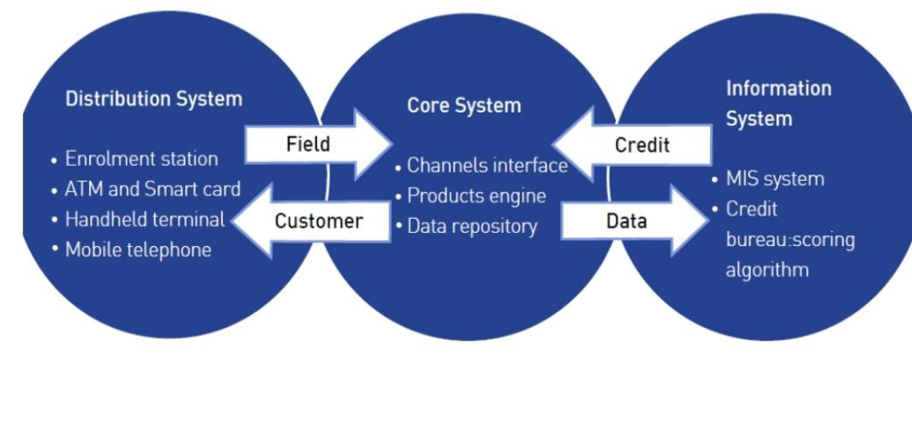

Financial Inclusion in India

* The financial landscape in India looks vastly different from that of other regions: There are roughly 50,000 very small community banks and credit unions spread across many rural areas. Anyone visiting these rural areas will quickly notice there are no ATMs, no debit cards and limited services.
* The banks themselves serve as merely a place for consumers to deposit and withdraw funds at a counter.
* As a result of the limited services, Mandar Agashe, founder, and managingdirector of Sarvatra Technologies, decided to develop a solution.
* Agashe set about helping smaller banks hook into a digital payment infrastructure and bring more consumers into the mix.
* After years of attempting to make India more digital, Agashe's quest was boosted by that country's demonetization, combined with its Unified Payments Interface (UPI). COVID-19 safety measures also helped elevate the project further when more Indian consumers were forced to stay at home, and thus, carry out more transactions online.
* In the first half of October 2020, UPI logged an enormous 1 billion transactions.
* The role of financial inclusion in reigniting the global economy in a postpandemic world cannot be understated. Ensuring universal access to financial products and utilities features in eight of the UN's seventeen Sustainable Development Goals, identified as an enabler for ending poverty and hunger and achieving gender equality.
* However, financial inclusion also has the power to boost economic growth and support industry and innovation. It will help nations, particularly emerging economies, find a path out of the fiscal damage wrought by the pandemic. A report by the McKinsey Global Institute previously estimated that digital finance would add $3.7trn to the GDP of emerging economies in the years leading up to 2025.
* But the overall idea of financial inclusion is still dogged by several misconceptions, including the idea that the problem is limited to low and middleincome countries. In the United States, the world's biggest economy, an estimated 22% of people are either unbanked or underbanked, meaning they're often losing money on short-term payday loans or check-cashing services.
* This leads to another common myth, not helped by the fact that -banking the unbanked|| has come to be the slogan of choice for solving the challenges of universal financial access. However, in the digital age, the idea of financial inclusion has evolved to mean something different than simply equipping everyone on earth with a checking account.

Traditional banks have fallen behind the digital curve

* Regulation is perhaps the most critical challenge facing the traditional banking sector when it comes to the issue of financial inclusion.
* According to Deloitte, it's a double-edged sword. Over recent years, regulation has proved to be a limiting factor in the ability of banks and traditional financial services providers to innovate and keep pace with the increasing shift to digital and mobile-first.
* However, compliance also creates high barriers to entry for banking services. In his recent letter to shareholders, Jamie Dimon, the CEO of JP Morgan Chase, highlights the Dodd-Frank regulation as actively preventing banks from lending more and supporting the economy.
* This combination has enabled nimbler, digital-native fintech firms to get ahead of their traditional counterparts; in some cases, banks simply can't compete in certain segments due to the heavier capital requirements placed on them versus the lighter regulation for their rivals in fintech.
* 134Financial Inclusion for Rural Development.
* The change is visible across the wealth spectrum, indicating that fintech is playing a pivotal role in financial inclusion while also emerging as a popular choice for more affluent consumers.

The rise of prepaid services

1. The rise in prepaid services is one of the more intriguing developments in enhancing universal access to products and services. It used to be the case that prepaid services were considered somewhat inferior to subscription-based plans.
2. However, the shift to mobile has well and truly reversed this perception, with consumers actively choosing prepaid mobile services over subscription-based models. Ding's findings showed that 61% of its 7,000 respondents used a prepaid mobile account, rising to 75% in Brazil, the Philippines, and the Gulf States.
3. Take-up of other prepaid services is also on the rise, with 45% of respondents saying they used two or more services, including prepaid utility bills, gift cards, vouchers, or credit cards.
4. A core reason for this shift is the speed and flexibility of prepaid services.
5. Anyone can purchase a SIM card and start using it instantly, topping up within a few seconds. Similarly, prepaid models allow users to have a high degree of control and visibility over their spending.

The future outlook

1. So what comes next? After all, the journey to universal financial inclusion is still underway.
2. Further development of the pillars underpinning the ongoing fintech transformation is critical to success.
3. For instance, while mobile penetration is high among the unbanked, increasing the availability of 4G and, eventually, 5G services will provide the bandwidth to offer a more sophisticated range of mobile-first financial services beyond pure payments and remittances.
4. These may include the provision of credit lines or insurance coverage, further narrowing the financial inclusion gap.
5. Finally, the success of platforms such as Europe's challenger banks and China's WeChat provide a blueprint for what financial inclusion success could look like in emerging economies, in the form of 'super apps.1
6. WeChat users can get updates from official government and company accounts, make everyday payments, book a medical appointment, apply for a loan, take a taxi, top-up their phone, and many more.
7. Revolut has expanded from being a convenient way to pay across borders into offering investments in commodities and crypto currencies, along with insurance services, savings plans, and other financial services
8. The ease and convenience of having all of these services in a single app, available across international borders, will be a huge step forward for inclusivity.
9. Ultimately, it seems likely that, for retail users at least, the role of traditional banks will diminish on the global stage as emerging economies continue their shift toward financial inclusion powered by fi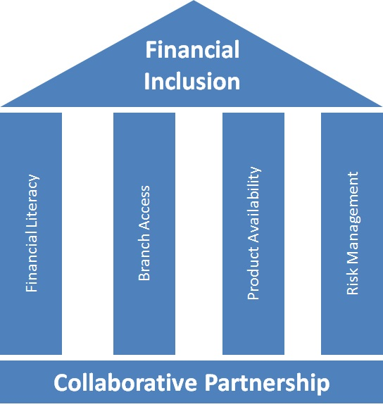ntech.

FINANCIAL INCLUSIONS - RURAL WOMEN ENTREPRENEURSHIP

* Financial inclusion is the expanding outreach of banking or financial services at an affordable cost to a vast section of disadvantaged groups of society which may provide them a financial cushion for their sustenance as well as social empowerment.
* In India where women constitute approximately 48.53 per cent (2011 census) of total population majority of them are denied to opportunities and rights because of their financial dependence.
* Through disbursement of funds by various methods of financial inclusion like self-help groups and microfinance by Banks an attempt has been made by the Govt.
* To provide women economic independence and self-confidence, as well as achieve more respect in their socially defined roles.
* Considering the importance of financial inclusion for the economy of the country the Government of India (Ministry of Finance), Reserve Bank of India and NABARD are adopting different measures for the financial inclusion.
* As such it is essential to know what the main causes for financial exclusion of women are.
* It is equally essential to have a clear idea on financial inclusion and empowerment.
* So in this chapter an attempt is made to study the causes and effects of financial exclusion.
* Besides an attempt is made to understand the meaning, importance and approaches.
* Financial inclusion and meaning and definitions of empowerment, historical background of women empowerment in India and measures for estimating women empowerment.
* Financial inclusion is one of the most important aspects in the present scenario for inclusive growth and development of economies.
* The financial inclusion term was first time used by British lexicon when it was found that nearly 7.5 million persons did not have a bank account.
* But financial inclusion concept is not a new one in Indian economy. Bank's Nationalization in 1969, establishment of RRBs and introduction of SHG- bank linkage programs were initiatives taken by RBI to provide financial accessibility to the unbanked groups.
* Financial inclusion can be described as the provision of affordable financial services, viz saving, credit, insurance services, access to payments and remittance facilities by the formal financial systems to those who are excluded. So, financial inclusion refers to access to vast range of financial product and services at affordable cost. It not only includes banking products but also other financial services such as loan, equity and insurance products.
* Households need access to finance for several purposes like creating buffer, retirement, saving to hedge against unpredictable situations and take products for insurable contingencies. Household also needs access to credit for livelihood creation, housing, consumption and their emergencies. Finally households require financial services to access a wide range of saving and investment products for wealth creation but it is all depends upon their level of financial literacy.
* Despite witnessing substantial progress in financial sector reforms in India, it is disheartening to note that nearly half of the rural households even today do not have any access to any source of funds- institutional or otherwise.
* Hardly one-fourth of the rural households are assisted by banks.
* Hence the major task before banks is to bring most of those excluded, i.e. 75% of the rural households, under banking fold. But the task is not so easy since they are illiterate, poor and unorganized.
* They are also spread far and wide. What is needed is to improve their living standards by initiating new/increased economic activities with the help of banks, NG0"s and local developmental agencies.
* To start with, it is necessary to develop a fair understanding of their profile. In addition, their perception about the bank and its services needs to be understood.
* So there is a need for the formal financial system to look at increasing financial literacy and financial counseling to focus on financial inclusion and distress amongst farmers.
* Indian banks and financial market players should actively look at promoting such programs as a part of their corporate social responsibility.
* Banks should conduct full day programs for their clientele including farmers for counseling small borrowers for making aware on the implications of the loan, how interest is calculated, and so on, so that they are totally aware of its features.
* There is a clearly a lot requires to be done in this area.
* Relevant data analysis and an outreach by women business correspondents can close our gender gap.
* Over the past year, the covid-19 pandemic has thrown existing inequalities into sharp focus.
* While the nation's attention has been drawn to the plight of migrant workers and farmers, the worsening gender gap has not received similar attention.
* Analysis of the Centre for Monitoring Indian Economy's Consumer Pyramids Household Survey data by researchers at Azim Premji University showed that women were seven times more likely to lose their jobs during last year's lockdown, and 11 times more likely to not return to work. An ongoing survey (tinyurl.com/z8f574vy) on micro, small and medium enterprises by Global Alliance for Mass Entrepreneurship and LEAD at Krea University shows that women-owned small businesses were hit more badly by the pandemic;
* 43% of women-owned enterprises surveyed reported monthly profit less than ?10,000, compared to just 16% of units owned by men.
* India's government was quick to announce and transfer ?500 per month for three months of lockdown last year to women through their Pradhan Mantri Jan Dhan Yojana (PMJDY) accounts.
* This seamless transfer of money was made possible by the Centre's direct benefit transfer-PMJDY linkage, but more importantly.
* This could happen because the government knew which accounts were held by women.
* Unfortunately, the lack of gender-disaggregated data in the banking sector overall meant that only PMJDY account holders received the benefit, and many other deserving women were left out.
* According to estimates by the Yale Economic Growth Center, more than half of India's women poor missed the cash transfers.
* While economic data is usually spliced by states, geographies (urban-rural) or sectors, the gender angle stays out of the common discourse. So though we all know that women employees and entrepreneurs traditionally face more challenges than men, the extent of disparity remains in the shadows. The case for genderdisaggregated data in banking and financial sectors is a first step towards closing the gender-gap in India. As a member of the Alliance for Financial Inclusion, India had pledged to close the gender gap in financial inclusion by implementing the Denarau Action Plan adopted in Fiji at the April 2016 Global Policy Forum. To redeem that pledge, we must first generate gender-wise data.
* The country's regional and social heterogeneity makes it crucial that this data be granular.
* The Reserve Bank of India (RBI) and Department of Financial Services (DFS) need to get this implemented.
* Second, apart from gender-specific data, there is another important initiative that the DFS and RBI should commit themselves to. That is the appointment of more women as business correspondents (BCs) by banks.
* The pay-offs will be manifold for economic and social progress in the country.
* One of the greatest challenges in increasing access to and usage of financial services by women is the time and cost expended on reaching a bank outlet.
* Although it is gratifying that a forthcoming working paper, The Fintech Gender Gap from the Bank for International Settlements, finds that Indian women are as likely to use fintech as Indian men, there are bound to be wide regional and rural- versus-urban disparities in this finding.
* 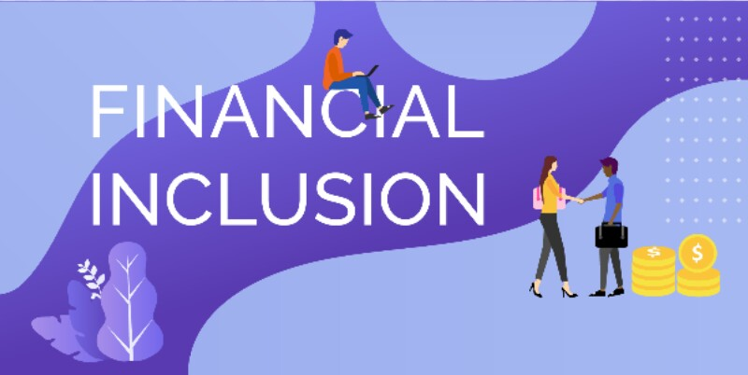That is another case for granular data. In states like Uttar Pradesh, Bihar, Rajasthan, etc., where the mobility of women is severely restricted, the situation is likely more serious. Women, in rural areas especially, are reluctant to visit bank branches, where they are often dealt with summarily by male staff.

FINANCIAL INCLUSION IN INDIA

* Financial inclusion defined as the process of ensuring access to financial services and timely and adequate credit where needed by vulnerable groups such as weaker sections and low income groups at an affordable cost (Dr. C. Rangarajan Committee (2008)).
* Financial inclusion is not a new trend in India. It has its existence with creation of co-operatives in 1904.
* Since then various efforts have been done by the Govt., RBI (Reserve Bank of India) and other regulatory bodies to boost the financial inclusion in the country.
* Nationalization of the Banks in 1969, establishment of Regional Rural Banks (RRBs) in 1975, greater focus on social banking and rural credit, directives to priority sector lending.
* Interest rate ceilings, subsidies through banks, no-frills accounts, simplification of KYC norms, SHGs bank linkage programme, promotion of banking reach through branchless BC/BF model, Pradhan Mantri Jana Dhan Yojana (PMJDY) scheme.
* National social security schemes named Pradhan Mantri Jeevan Jyoti Bima Yojana (PMJDY), Pradhan Mantri Suraksha Bima Yojana(PMSBY) and Atal Pension Yojana (APY) are some of the prominent measures.
* After all these measures also, some extent of the population is still financially excluded.
* To include all the financially excluded in to the formal banking fold the Government of India announced 'National Strategy for Financial Inclusion
* India 2019-2024'to ensure the formal financial services to the financially excluded and to broaden, deepen and promote the financial literacy.

Objectives

1. To study the Population Group(Rural, Urban, Semi Urban and Metropolitan) and Bank Group-Wise Deposits of Scheduled Commercial Banks
2. To study the ownership category of Population Group(Rural, Urban, Semi Urban and Metropolitan)gender-wise

3. To study the population group and bank group-wise classification of outstanding credit

Review of Literature

* In recent years notable growth is marked in terms of bank branch penetration in India (Paramjit Sujlana Chhavi Kiran, 2018).
* Banking is a primary source to augment financial inclusion.
* A well performing banking system is indicator of financial inclusion achievement. Performance of banks is directly related to financial inclusion (Priyanka Koorse et al, 2015).
* Financial inclusion has positive effect on banks performance(Prince Asare Vitenu Sackey, Jiang Hong Li, 2019).
* Increase in bank branches has positive effect on both credit and deposit penetration(Nitin Kumar,2010) and MSME financing increases the deposit in the banks (Abubakar GarbaRazaq et all, 2018).
* There is disparity in credit penetration to farmer community (Small and Big) and other agri-businesses.
* Banks must create new methods to reach rural India without any variation (Gourav Vallabh & Suraj Chatrath, 2006).

Methodology

* Secondary data was used to study divergence of financial inclusion indicators.
* Data has been collected from Reports of Reserve Bank of India. Rural, Semi Urban, Urban and metropolitan category was used to study the population groups.
* Gender and population group wise analysis was done in Deposit penetration.
* Population and bank group wise data was analyzed to study credit penetration.
* Percentages were used for data analysis.

V. Financial Inclusion in India

Table 1: Population Group and Bank Group-Wise Deposits of Scheduled Commercial BanksAccording to Type of Deposits- March 2020

(No of Accounts in Thousands and Amount (Rs.Crore)

|  |  |  |  |  |  |  |  |  |  |  |
| --- | --- | --- | --- | --- | --- | --- | --- | --- | --- | --- |
| **Rural Batiks** |  |  |  |  |  |  |  |  |  |  |
|  | Semi-  urban | 4783 | 938 | 2763 | 57066 | 60321 | 4472 | 55623 | 62476 | 118707 |
|  | Urban | 1570 | 408 | 1973 | 11286 | 23277 | 2188 | 45093 | 13882 | 70343 |
|  | Metropol  itan | 425 | 51 | 560 | 2209 | 5130 | 395 | 12035 | 2654 | 17725 |
|  | **ALL INDIA** | **22130** | **3049** | **9442** | **247129** | **244475** | **17317** | **213505** | **267495** | **467422** |
| **Private**  **Sector**  **Banks** | Rural | 7200 | 1661 | 10585 | 31744 | 59548 | 4374 | 58866 | 37778 | 128999 |
|  | Semi-  urban | 10880 | 3833 | 45932 | 58957 | 189833 | 9197 | 238149 | 71988 | 473915 |
|  | Urban | 7355 | 4906 | 93475 | 55875 | 287925 | 12100 | 448057 | 72880 | 829457 |
|  | Metropol  itan | 9538 | 10565 | 362510 | 91469 | 635114 | 23809 | 1547762 | 125843 | 2545386 |
|  | **ALL**  **INDIA** | **34973** | **20965** | **512503** | **238045** | **1172420** | 49479 | **2292834** | **308489** | **3977757** |
| **Small Finance Bank** | Rural | 812 | 26 | 70 | 1303 | 962 | 224 | 1670 | 1552 | 2703 |
|  | Semi-  urban | 1618 | 86 | 312 | 5766 | 2676 | 652 | 6870 | 6504 | 9857 |
|  | Urban | 1029 | 84 | 639 | 3808 | 3737 | 591 | 13366 | 4484 | 17742 |
|  | Metropol  itan | 730 | 79 | 1217 | 2636 | 2908 | 568 | 28239 | 3283 | 32364 |
|  | **ALL**  **INDIA** | **4189** | **275** | **2238** | **13513** | **10284** | **2034** | **50145** | **15823** | **62667** |
| **ALL INDIA** | | **153102** | **86007** | **1273756** | **1729600** | **4515859** | **253441** | **7959040** | **2069047** | **1374865**  **5** |

From Table 1, it is evident that a majority of total deposits are from Public sector banks with 1469886 accounts, amounting to Rs.8576021 crores ason March 2020.

* The number of deposit accounts of Private Sector banks and RRBs stood at 308489 and 267495 with the corresponding amount of Rs. 3977757 crores and Rs. 467422 crores.
* Thus, more than 70% of the deposit accounts emanate from public sector banks. The rural group has highest number of accounts in public sector banks and RRBs, possessing more number of savings account holders.
* The metropolitans accounted for higher deposit amount in all the bank groups except RRBs.
* The Private sector banks and RRBs accounted for 15% and 13% of total number of deposits respectively.
* The amount of deposits mobilized by the private sector banks is more than that of the RRBs. From population group-wise analysis, it is quite apparent that RRBs opened more number of deposit accounts and procured highest amount in rural segment.
* Among the deposits, savings account recorded high both in terms of number of accounts. Nevertheless, the term deposit amount is more among all the bank groups except in case of RRBs, whose savings deposit amount is higher.
* It is interesting to note that the current and term deposit amounts of foreign banks are higher in rural than that of semi-urban segment.

|  |  |  |  |  |  |  |  |  |
| --- | --- | --- | --- | --- | --- | --- | --- | --- |
| **Population**  **Group Description** | **Individuals** | | **of which Female** | | **Others** | | **Total** | |
| **No of Accounts** | **Amount** | **No of Accounts** | **Amount** | **No Of**  **Accounts** | **Amount** | **No of Accounts** | **Amount** |
| Semi-urban | 553913 | 1459807 | 173782 | 450823 | 34934 | 600941 | 588848 | 2060748 |
| Urban | 316855 | 1664386 | 106462 | 553384 | 21893 | 1032667 | 338747 | 2697053 |
| Metropolitan | 346347 | 2816575 | 114969 | 959232 | 31317 | 3707339 | 377664 | 6523914 |
| **ALL INDIA** | **1854483** | **7087953** | **607980** | **2303348** | **118237** | **5551056** | **1972720** | **12639009** |

* Displays the number of bank accounts and the amount held categorywise with the banks as on March 2019.
* Of the total 1972720 accounts, 1854483 are individual accounts (including Hindu Undivided Families with Rs. 7087953 crores) of which female accounts number is 607980; and other entities (all other entities excluding individuals) numbered to 118237 with Rs. 5551056 crores.
* Of 667461 accounts held in rural segment, the individuals accounted for 637368, out of which 212766 are females; and other entities being 30093.
* Although the deposit amount is lowest in the rural segment, it can be observed that the number of individual accounts registered is 94% of the total and the female accounts are about 30%.
* Table also reveals that rural deposit accounts are 34%, semi urban 30%, urban 17%, and metropolitan 19% of total deposits.
* It indicates the fact that the scheduled commercial banks opened more number of accounts in rural compared to those in other segments, thus, initiating the way towards financial inclusion.
* Population Group And Bank Group-Wise Classification of Outstanding Credit of Scheduled Commercial Banks According to Occupation - March 2019
* From Table 3, it can be seen that the number of accounts, credit limit and outstanding amount are recorded high in public sector banks, followed by RRBs, private sector banks and foreign banks among the rural segment.
* But, across other segments, the credit limit and outstanding amount is higher in private sector banks than that of the RRB.
* Thus, all SCBs (scheduled commercial banks) except foreign banks extended more credit limit to agriculture, industry and trade in rural and semi-rural regions.
* The foreign banks credit limit is higher in personal loans.
* All SCBs, except private sector banks extended more credit limit to agriculture, personal loans semi-rural regions.
* In urban segment, all SCBs credit limit is extended more to personal loans except small finance banks, which focused on finance and agriculture occupations.
* In metropolitan segment too, similar pattern can be observed (excepting small finance banks).
* Besides, the SCBs seem to grant credit limit to agriculture and the industry occupations as well.



FINANCIAL INCLUSION OF RURAL INDIA: CHALLENGES & OPPORTUNITIES

* Agriculture is the backbone of the Indian Economy; it will continue to be paramount.
* We need modern agriculture that is driven the latest technologies.
* India which is a developing country has its eyes set on becoming $5-tri I lion economy by 2025.
* To achieve this target the Indian economy needs to grow @9% per year.
* The aim of the Indian Government is becoming -Atman nirbhar Bharat or a Self-Reliant India is another goal.
* The Indian Government announced a package to the tune of Rs 20 lakh crore to revive the Economy.
* However, one important area that really needs to be focused upon is rural inclusion, Which helps in achieving the above said dual objectives.
* The rural economy contributes nearly 25-30% to the GDP.
* Agriculture was the
* primary source of income and employment in rural India, but now it is displaced by non-farm and other non-agricultural sectors.
* Thus, for bringing the rural revitalisation, we need a transformative approach that will make our rural areas and better place to work and live in.
* Affordable and appropriate access to financial services is increasingly being recognised world over as a key driver of economic growth, poverty alleviation and prosperity.
* Access to formal finance can boost job creation, reduce vulnerability to economic shocks and increase investments in human capital.
* At a macro-level, greater financial inclusion can support sustainable and inclusive socio-economic growth for all.

Current Scenario: Challenges& Opportunities

* There a lot of challenges ahead for revitalising the county into fully digital and financial inclusion would remain a dream unless the followings are addressed.
* The main focus should be on the providing basic infrastructure facilities for accessing basic banking facilities and awareness should be created regarding the various schemes.
* According to the secondary research sources 87% of rural population uses mobile phones to access internet services.
* which shows that there is a huge opportunity to tap into this segment of people.
* Another important area which is to be focused is building a robust Technology Infrastructure.
* Though the usage of mobile devices is high in rural areas, many if them 113Financial Inclusion for Rural Development still lack proper internet connections.
* In this connection, Bharat Net Project will be able to boost digital inclusion in Indian Villages as it seeks to provide internet connectivity to 2,50,000-gram panchayats in India.
* In addition digital banking had gained a popularity in the urban areas but because of the lack of digital literacy it has not been able to gather steam in rural India.
* India needs modern agriculture that is driven by latest technologies and markets. Hence financial growth and inclusion needs to be driven by agro-based industrialization.
* This requires investments to be made in post -harvest rural activities like agro-processing .cold chains, packaging cold storage and their transport.
* Private sector investments play a very vital role in creating a favourable environment in rural areas, developing specific Agro -based „Special Economic Zones" in villages will boost the economies and increase the employment opportunities.
* More jobs can be increased in rural areas by creating a strong linkage between the farm and non -farm sectors of the economy.
* Through such linkages, the farm sector will be able to produce market-oriented commodities, slash their transportation costs, receive excessively remunerative prices at the farm gate and reduce farm wastage.

MSME - Backbone of Indian Economy

1. MSMEs are very important for rural industrialization as their products constitute a large share of exports and generates a lot of employment opportunities for millions of workers. MSME units contribute more than 90% of total industrial units in India.
2. To promote national economy Government is taking several steps to boost manufacturing sector.
3. Government's intention towards industrialization can be analysed through formation of various institutions for policy designing and allocation of funds through Five Year Plans.
4. Formation of National Manufacturing Competitiveness Council by Government suggest ways to enhance competitiveness in the manufacturing sector to make sector globally competitive.
5. Government has announced National Manufacturing Policy for raising the share of manufacturing to 25% of GDP by 2022.
6. Make in India announced in September 2014 by New Government aims at to make India a Global Manufacturing hub.

Role of Panchayats

* To raise the awareness, the panchayats with a wide coverage can paly a vital role in enabling financial inclusion of rural India by spreading the financial literacy

Challenges

Despite the various measures that have been under taken by various take holders in strengthening financial inclusion in the country, there are still critical gapsexisting in the usage of financial services that require attention of policy makers through necessary co-ordination and effective monitoring.

Inadequate Infrastructure:

Limited physical infrastructure, limited transport facility, inadequately trained staff etc., in parts of rural hinter land and farflungareas of the Himalayan and North Eastregionscreatea barrier to the customer while accessing financial services.

Poor Connectivity:

With technology becoming an important enabler to access financial services, certain regions in the country that have poor connectivity tend to be left behind in ensuring access to financial services thereby creating a digital divide.

Technology could be the best bridge between the financial service provider and the last mile customer.

Fin tech companies can be one of the best solutions to address this issue.

The key challenge that needs to be resolved would be improving teleand internet connectivity in the rural hinterland and achieving connectivity across the country.

Convenience and Relevance:

The protracted and complicated procedures actasadeter rent while on-boarding customers.

This difficulty is further increased when the products are not easy to understand, complex and do not meet the requirements of the customers such as those receiving erratic and uncertain cash flows from their occupation

Socio-Cultural Barriers:

Prevalence of certain value system and be liefs in some sections of the population results in lack of favourable attitude towards formal financial services.

There are still certain pockets wherein women do not have the freedom and choice to access financial services because of cultural barriers.

Product Usage:

While the mission-based approach to financial inclusion has resulted in increasing access to basic financial services including micro insurance and pension, there is a need to increase the usage of these accounts to help customers achieve benefits of relevant financial services and help the service providers to achieve the necessary scale and sustainability.

Payment Infrastructure:

Currently, majority of the retail payment products viz., CTS, AEPS, NACH, UPI, IMPS etc.

Are operated by National Payments Council of India (NPCI),a Section(8) Company promoted by a group of public, private and foreign banks.

There is a need to have more market players to promote in novation & competition and to minimize concentration risk in the retail payment system from a financial stability perspective.



CONCLUSION

Financial inclusion is the new concept which helps to attain the sustainable development of the country. It provides banking and financial services to all citizens in a fair, visible and reasonable manner at affordable cost. The poorer income Households often lack to access bank account and have to spend time money for several visits to achieve the banking services.

Financial inclusion is help to the sustainable societal and economic improvement of the country. It helps to the empowerment of underprivileged, poor and women of the society with the mission of creation them self-reliant and well learned to take superior financial decisions.

Financial inclusion takes into the involvement of vulnerable groups such as weaker sections of the general public and low income groups, based on the extent of their access to financial services such as savings and payment account, credit insurance, pensions etc.

Financial inclusion implement to easy accessibility of financial services which allows utmost investment in business, education, insurance against risks, save for retirement etc. by the rural people and firms.

The nationalization of banks, priority sector lending necessities for banks, cooperative banks, lead bank scheme, establishment of Regional rural banks (RRBs), self-help group-banketc.

The Reserve Bank of India (RBI) take the step to increase access to the poor segments of society.

The Reserve Bank of India has ensure accessible financial services and to increase the speed of financial inclusion to set up a high stage committee on October, 2012.

The RBI Deputy Governor to be headed by Financial Inclusion Advisory Committee.

The World Bank Global Financial Inclusion (Global Findex) Database indicates that 2.5 billion adults globally which comes to about half the total adult population in the world- has zero access to financial services offered by regulated financial institutions. While in high-income economies, 89 percent of the adult respondents reported that they have an account in a formal financial organisation; the number comes down to only 41 percent in developing economies.

Due to a lack of proper access, the poor people are forced to rely on unscrupulous moneylenders for credit at very high rates of interest; they use various assets such as livestock or gold etc., as a form of savings...

BIBILOGRAPHY

[www.wikipedia.com](http://www.wikipedia.com) [www.mdpi.com](http://www.mdpi.com)

[www.researchgate.com](http://www.researchgate.com)

[www.123helpme.com](http://www.123helpme.com)